**Name: Sreelakshmi M Nair**

**Roll No: 40**

**Batch: B**

**Date: 09/05/2022**

**NETWORKING & SYSTEM ADMINISTRATION LAB**

**Experiment No.: 9**

**Aim**

write shell script to display current date and calender

**Program**

#!/bin/bash

echo "current date:"$(date)

echo "current year calender:"

cal

**Output:**

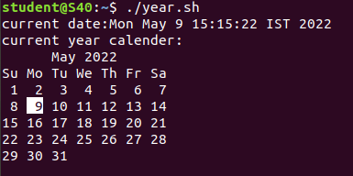

**Experiment No.: 10**

**Aim**

write shell script to find number is greater ,less than or equal to another number.

**Program**

#!/bin/bash

echo "Enter first number : "

read num1

echo "Enter second number : "

read num2

if [ $num1 -gt $num2 ]

then

echo "First Number is Greatest!!"

elif [ $num1 -lt $num2 ]

then

echo "Second Number is greatest!!"

elif [ $num1 -eq $num2 ]

then

echo "First and Second Number is Equal.."

fi

**Output:**

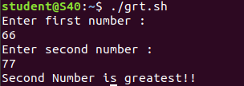

**Experiment No.: 11**

**Aim**

write shell script to find sum of first 10 numbers.

**Program**

#!/bin/bash

echo "Enter Size(N)"

read N

i=1

sum=0

echo "Enter Numbers"

while [ $i -le $N ]

do

read num #get number

sum=$((sum + num)) #sum+=num

i=$((i + 1))

done

echo $sum

fi

**Output:**

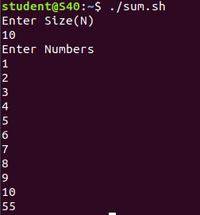

**Experiment No.: 12**

**Aim**

write shell script to find the sum ,the average and the product of the four numbers.

**Program**

#!/bin/bash

echo "enter four integers"

read a b c d

sum=$(echo "$a + $b + $c + $d" | bc -l)

average=$(echo "$sum / 4" | bc -l)

product=$(echo "$a * $b * $c * $d" | bc -l)

echo "sum = $sum"

echo "Average = $average"

echo "Product = $product"

**Output:**

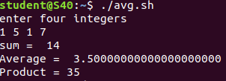

**Experiment No.: 13**

**Aim**

write shell script to find factorial of a given number

**Program**

#!/bin/bash

echo "Enter a number"

read num

fact=1

while [ $num -gt 1 ]

do

fact=$((fact * num)) #fact = fact * num

num=$((num - 1)) #num = num - 1

done

echo $fact

**Output:**

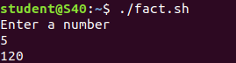

**Experiment No.: 14**

**Aim**

write shell script to check whether the number is palidrome or not .

**Program**

#!/bin/bash

echo "Enter the number"

read n

number=$n

reverse=0

while [ $n -gt 0 ]

do

a=`expr $n % 10 `

n=`expr $n / 10 `

reverse=`expr $reverse \* 10 + $a`

done

echo $reverse

if [ $number -eq $reverse ]

then

echo "Number is palindrome"

else

echo "Number is not palindrome"

fi

**Output:**

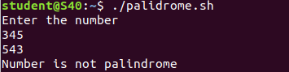

**Experiment No.: 15**

**Aim**

write shell script to check whether the given year is leap year or not .

**Program**

echo "enter the year :"

read y

a=`expr $y % 4`

b=`expr $y % 100`

c=`expr $y % 400`

# -eq is for equal to

#-ne is for not equal to

if [ $a -eq 0 -a $b -ne 0 -o $c -eq 0 ]

then

echo "$y is leap year"

else

echo "$y is not leap year"

fi

**Output:**

